*Solo Project*

*Lab in Psychology*

*Nirja Sukhadia*

*AU2120057*

*Topic – Distraction and its effect on cognitive efficiency*

*Github link -*

**Introduction**

Attention has a limited capacity for processing information at a time. While a lot of research has been done in the field of attention, it is widely known fact that attention has a limited capacity and thus can be directed towards a particular stimulus in a specific magnitude at a time. The ability to focus on a specific stimulus while ignoring the irrelevant stimuli is known as selective attention. Broadbent’s Filter Model emphasizes on the concept of selective attention by conceptualizing attention as a bottleneck mechanism. This means that only a limited amount of information is allowed to enter for processing, which is filtered on the basis of physical characteristics of the stimuli. (Broadbent, 1957). However, when multiple stimuli compete for attention, cognitive load tend to increase further resulting in declining of performance.

In today’s world almost each and every one of us have smartphones, being one of the major reasons for decreasing attention span in humans. Research shows that average attention span on any screen was 2 and a half minutes in 2004, while in 2012, it became 75 seconds. (Mark, 2023). It is shocking to know that the average attention span of a human now is only 8.25 seconds (Treetop, 2024). This is due to the increasing distractions on the internet. We are constantly flooded with information that we do not need with social media. The effect digital notifications have on our minds is fascinating, one minute you are engrossed in the assignment you are working on and the next you are scrolling on social media platforms mindlessly, getting distracted by one notification sound. According to Dr Gloria Mark, this constant switching between tasks leads to increased errors, stress, fatigue, reduced productivity. When people shift their attention very fast between different things (also called multitasking) they tend to make more errors because of switching costs. Every time one switches their attention, they have to reorient to that new task taking more time and effort (Mark, 2023).

Selective attention span and decreasing attention span are deeply correlated becoming a reinforcing cycle. Decreased attention span leads to poor selective attentions as there is reduced ability to ignore the distractions or irrelevant stimuli. Further, this decreased attention span leads to poor selective attention as it fails to manage distractions effectively and reinforces the practice of fragmented focus and continuing this cycle. Studying this interplay of attention span and selective attention can help us formulate strategies to avoid distractions and focus on the task assigned effectively.

With this experiment we try to understand the effect of different types of distractors on selective attention, task performance and cognitive control. The aim of this experiment is to measure how auditory and visual stimuli affect the time taken to complete a task and the accuracy of the responses reported. The participants would face issues solving the problems in the presence of distractors, further increasing the task completion time and also impacting the accuracy of the responses. The hypothesis we are trying to test here is that the average task completion time would increase in the presence of auditory and visual distractors.

**Method**

To test the hypothesis, a problem-solving task and manipulation of different factors of distractions is used in the experiment.

*Apparatus and Stimuli*

The target stimuli in the experiment are the simple arithmetic problems consisting of 3 digits and only two mathematical operations – addition and subtraction. The problems were formulated randomly by the experimenter. A single dependent variable is chosen here to analyse the effects of IVs which is – task completion time. The experiment uses a 2x2 within-subjects design, to examine the effects of independent variables on dependent variables. The independent variables here are presence of distraction, and the type of distraction. Both these IVs have two levels as shown in the table below.

|  |  |
| --- | --- |
| **Independent Variables** | **Levels** |
| Presence of distraction | Present or Absent |
| Type of distraction | Auditory or Visual |

*Design*

The experiment was designed using PsychoPy software on a 16” laptop. In this experiment, there would be two routines – control which would be the baseline characteristic where there would be no distraction, and treatment with two levels of type of distractions would be present. A total of 10 arithmetic problems were presented to the participant. In the control routine, a random loop type and nReps=1 was added with the conditions file containing problems and their correct response. In the treatment routine, a random loop type and nReps=1 was added with a different conditions file consisting of test_problems, their correct responses, opacity and intensity. Opacity and intensity here refer to the characteristic of visual and auditory distractors, respectively. When intensity would be 1, opacity would be 0 and vice versa to ensure that both the distractors would not be presented together.

*Procedure*

The participants for the experiment were of 21 years of age from Ahmedabad University and were chosen randomly. The participants started the experiment in an undisturbed environment. They would first be presented with instructions and start with the control routine. The participants are supposed to solve the arithmetic problem without the use of calculator, and report their answers in the text box provided, followed by pressing “click to submit” button. Once the control routine ended, a text saying “Round 2” would appear and treatment routine would start. In the treatment round the participants would again follow the same procedure of solving the problem and reporting the answers, but along with randomly occurring distractors, either auditory or visual. All the participants would go through both the routines, control and treatment, enabling a within-subjects design. However, in both the routines different arithmetic problems of the same difficulty level would be presented to avoid the practice effect.

**Results**

The data of all 5 participants were stored in separate csv files. Each participant’s data was cleaned and sorted by removing irrelevant data and kept the columns that had data related to the responses reported, trial start time, and trial end time for both the routines (control and treatment). Analysis was done by comparing the average time taken in different conditions and further a paired t-test was done to compare the means of two different groups of conditions and helped in determining if there is a statistically significant difference between the means of the groups. The tables below show the average time taken to complete the task by each participant under different conditions.

|  |  |  |
| --- | --- | --- |
| **Participant** | **Without Distraction** | **With Distraction** |
| 1 | 5.751 | 11.0244 |
| 2 | 10.9757 | 12.4033 |
| 3 | 4.3849 | 6.7227 |
| 4 | 5.6455 | 17.57007 |
| 5 | 7.4587 | 8.1028 |
| Total Average | 6.8433 | 11.1646 |

*Table 1. Average time take to complete the task in 2 different conditions (in secs)*

|  |  |  |
| --- | --- | --- |
| **Participant** | **Without Distraction** | **Audio_distractor** |
| 1 | 5.7517 | 11.55086 |
| 2 | 10.9757 | 9.8052 |
| 3 | 4.3849 | 6.9466 |
| 4 | 5.6455 | 16.027 |
| 5 | 7.4587 | 9.5325 |
| Total Average | 6.8433 | 10.7724 |

*Table 2. Average time taken to complete the task in presence of audio_distractor (in secs)*

|  |  |  |
| --- | --- | --- |
| **Participant** | **Without Distraction** | **Visual_distractor** |
| 1 | 5.7517 | 10.4979 |
| 2 | 10.9757 | 15.0013 |
| 3 | 4.3849 | 6.4985 |
| 4 | 5.6455 | 19.113 |
| 5 | 7.4587 | 6.6607 |
| Total Average | 6.8433 | 11.5542 |

*Table 3. Average time taken to complete the task in the presence of visual_distractor*

|  |  |  |
| --- | --- | --- |
| **Participant** | **Audio_distractor** | **Visual_distractor** |
| 1 | 11.55086 | 10.4979 |
| 2 | 9.8052 | 15.0013 |
| 3 | 6.9466 | 6.4985 |
| 4 | 16.027 | 19.113 |
| 5 | 9.5325 | 6.6607 |
| Total Average | 10.7724 | 11.5542 |

*Table 4. Average time taken to complete the task in presence of different types of distractors*

| **Descriptives** | | | | | | | | | | | | | | |
| --- | --- | --- | --- | --- | --- | --- | --- | --- | --- | --- | --- | --- | --- | --- |
|  | | *N* | | *Mean* | | *SD* | | *SE* | | *Coefficient of variation* | | | | |
| *Without Distraction* |  | *5* |  | *6.843* |  | *2.556* |  | *1.143* |  | *0.373* | | | |  |
| *Audio_distractor* |  | *5* |  | *10.772* |  | *3.366* |  | *1.505* |  | *0.312* | | | |  |
| *Visual_distractor* |  | *5* |  | *11.554* |  | *5.469* |  | *2.446* |  | *0.473* | | | |  |
|  | | | | | | | | | | | | | | |
| **Paired Samples T-Test** | | | | | | | | | | | | | |
| *Measure 1* | |  | | *Measure 2* | | | | *t* | | *df* | | *p* | |
| *Without Distraction* |  | *-* |  | *Audio_distractor* | | |  | *-2.010* |  | *4* |  | *0.115* |  |
| *Without Distraction* |  | *-* |  | *Visual_distractor* | | |  | *-1.971* |  | *4* |  | *0.120* |  |
| *Audio_distractor* |  | *-* |  | *Visual_distractor* | | |  | *-0.533* |  | *4* |  | *0.622* |  |
|  | | | | | | | | | | | | | |
| Note.  Student's t-test. | | | | | | | | | | | | | |

The null hypothesis here is that there is no significance difference between the response time of the two groups. “Without Distraction” vs “Audio Distraction” – The t-test shows that the p-value is greater than 0.05, implying that we fail to reject the null hypothesis. Meaning there is no difference in the task completion time in the two conditions, that when the task is completed in the without the distractor and when in presence of audio distractor. The same goes for the other two conditions as the p-value is greater than 0.05 there also. Hence, there is no statistically significant difference between the mean values of the above groups, and we fail to reject the null hypothesis. The graphs below show the mean values of the reaction time in the above three conditions.

**Descriptive plots**

The graphs below represent the average time taken to complete the task by the participant in two different conditions, in seconds. The y-axis shows the average task completion time and the x-axis shows the two experimental conditions compared. The data points in the graph represent the average task completion time and the error bars show the variability or uncertainty in the data. The error shows tell us how much the correct average might be different from sample averages.

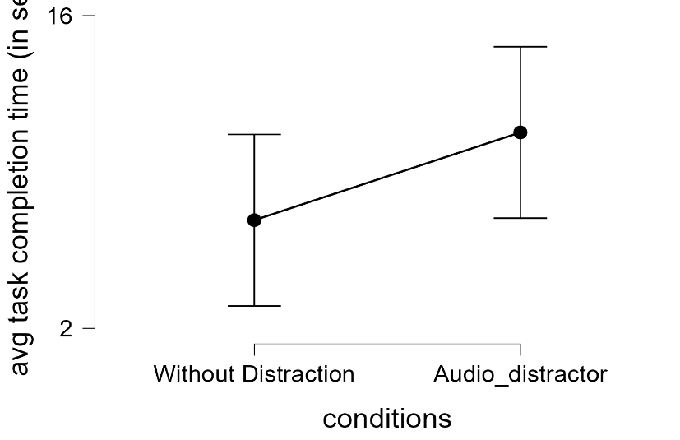

*Figure 1. The average task completion time is higher when there is auditory distractor than in without distraction condition.*

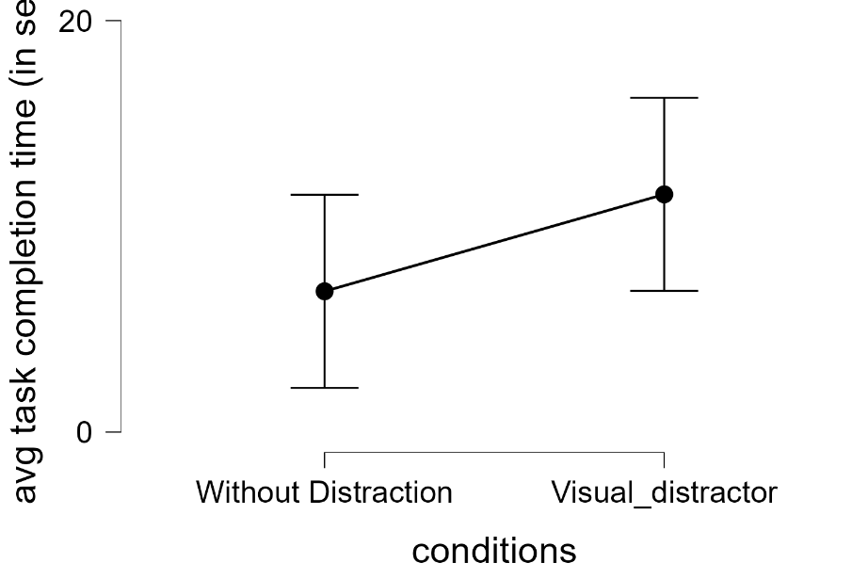

*Figure 2. The average task completion time is higher when visual distractor is presented than without distraction condition.*

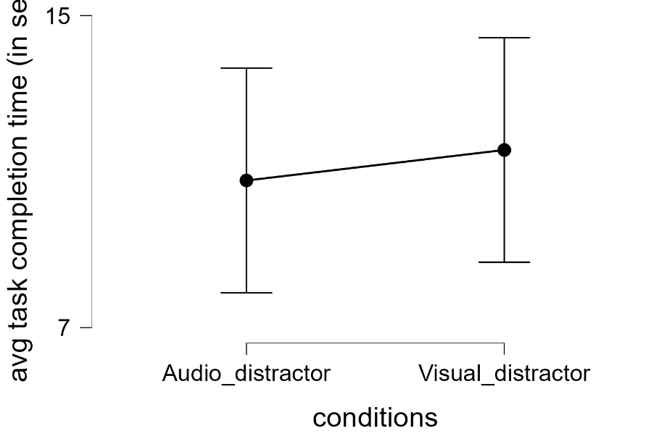

*Figure 3. The average task completion time is almost same here with slightly more in visual distractor.*

**Discussions**

The findings of this study show increased task completion time when the auditory and visual stimuli are presented. The time taken to solve the task in distracting conditions was higher than that in without distraction condition but the difference is not very significant. By the t-test analysis, we found out that the differences in the mean of the groups are not statistically significant. However, the difference in the task completion time between control routine (without distraction routine) and treatment routine (with distraction routine) was very less. This may be due to simplicity of the problems presented making participants report their answers easily and faster. Another reason could be less impactful distracting stimuli, intensity and the frequency of the auditory stimuli could be increased. Increasing the frequency in a single trial would make the auditory stimuli more impactful. One of the major reasons according to me for less impact of distracting stimuli could be due desensitization to the distractors. All the participants recruited for the experiment were of the age 21, implying young adults who are used to getting constant notifications and are already overexposed to these types of distractors on daily basis. This could lead them to become desensitised to distractors and may not affect or interrupt their task performance. Had the experiment been on a different age group of population who is not much exposed to these notifications, like the 45-60 age group, the impact of distractors would have been effective in the experiment.

*Theoretical Implications of the study –* The experiment helps us understand how selective attention works in the presence of multiple stimuli and how it affects the task at hand. The findings also support the capacity theory by Kahneman suggesting that multitasking is a myth and is constrained by the limited availability of attentional resources (Moran, 2011). By analysing the effects of auditory and visual distractors separately, this experiment can also help us understand the modality-specific interference, meaning exploring whether certain sensory stimuli are more distracting than the others.

*Practical Implications of the study -* Selective attention and workload theories can help us understand and deal with workload productivity, helping in delegating the right amount of work, minimizing on distractions in an organisation. This can also give insights into the technological designs for digital notifications, making them less intrusive and distracting. Some of the daily-life situations where the findings of the experiment can be applicable are road safety especially while driving, educational strategies, cognitive training for people with ADHD by reducing susceptibility to distractions, and enhancing focus. The experiment design can be reframed and replicated in better way keeping in mind the limitations of this experiment to gain insights about the psychological process and applying the findings in the real-world.

# References

Broadbent, D. E. (1957). A MECHANICAL MODEL FOR HUMAN ATTENTION. *Psychological Review*.

Mark, D. G. (2023, February). Why our attention spans are shrinking, with Gloria Mark, PhD. (K. M. (APA), Interviewer)

Moran, A. (2011). Attention. *Science Direct*, 319-335.

Treetop, T. (2024, July 17). *ABA Therapy*. Retrieved from The Treetop: https://www.thetreetop.com/statistics/average-human-attention-span